**CN Assignments – Raw Sockets 15-3-2022**

**1.** **Passport Issuer**

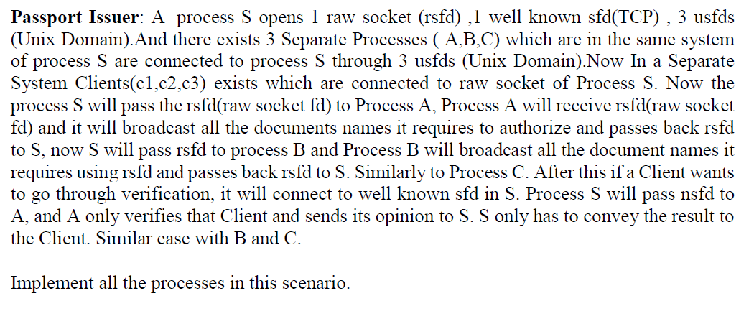

**2.** **NIT - Cricket**

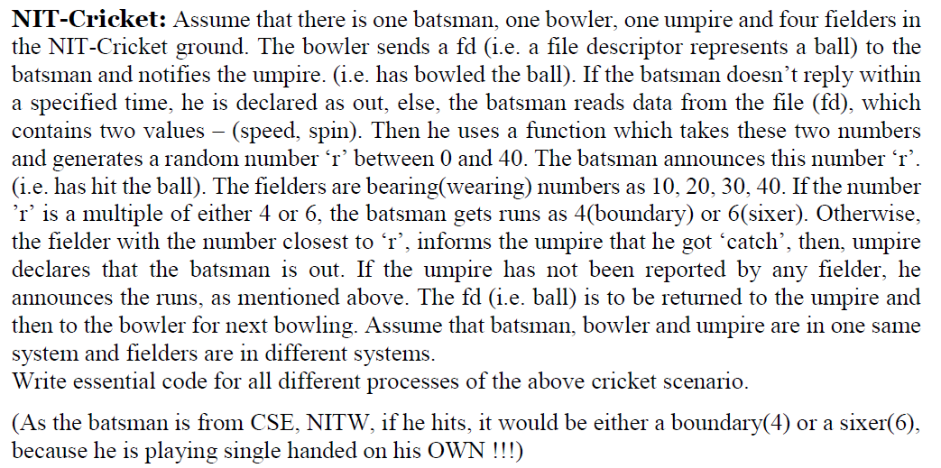

**Odd Roll numbers have to do Question 1**

**Even Roll Numbers have to do Question 2**

**Submission link will be sent mostly from 11 PM.**

**For similar codes Submission time is specially noted.**